**Traveling to the LA airports**

In order to gain a better understanding of our project, our team made an attempt to visit the 5 major airports that were located in the LA Basin. On November 11th, one of our team members flew down to John Wayne Airport and then on November 13th flew back up through Long Beach Airport.

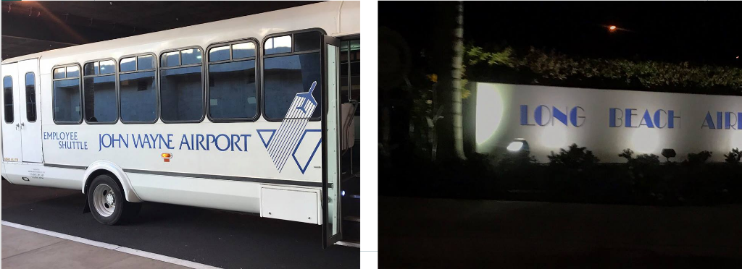**Pictures we took of the respective airports.**

Long beach

Several things we found were interesting in our Long Beach Airport visit. First off was the structure of this airport in comparison to LAX. The size of Long Beach was tiny in comparison, having a much narrower security checkpoint and consist of two separate buildings for passenger waiting areas. The ceiling within these buildings were approximately twenty feet in height, which contributes to the overall feeling of spaciousness even though the airport was small. Traveling between links, most of the journey was actually outdoors. The link between the security check in and passenger waiting areas are exposed outdoors. Long Beach doesn’t have any gateways, instead passengers walk outside on the apron, and board the plane through stairs.

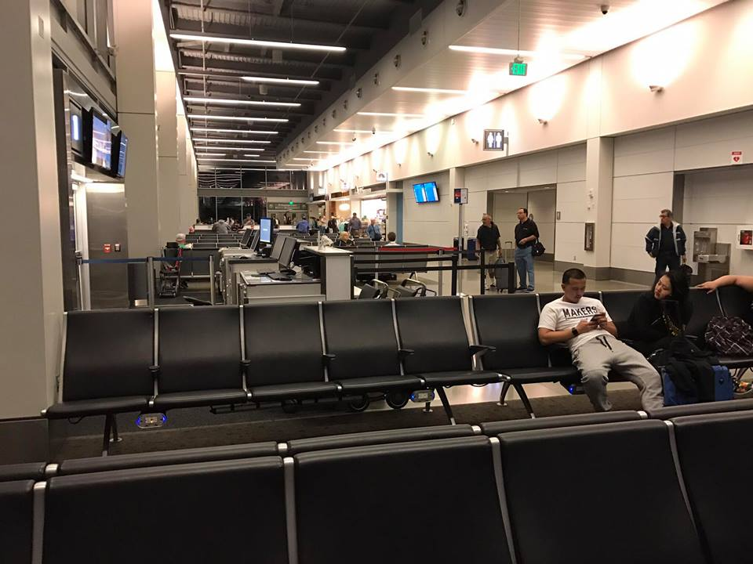 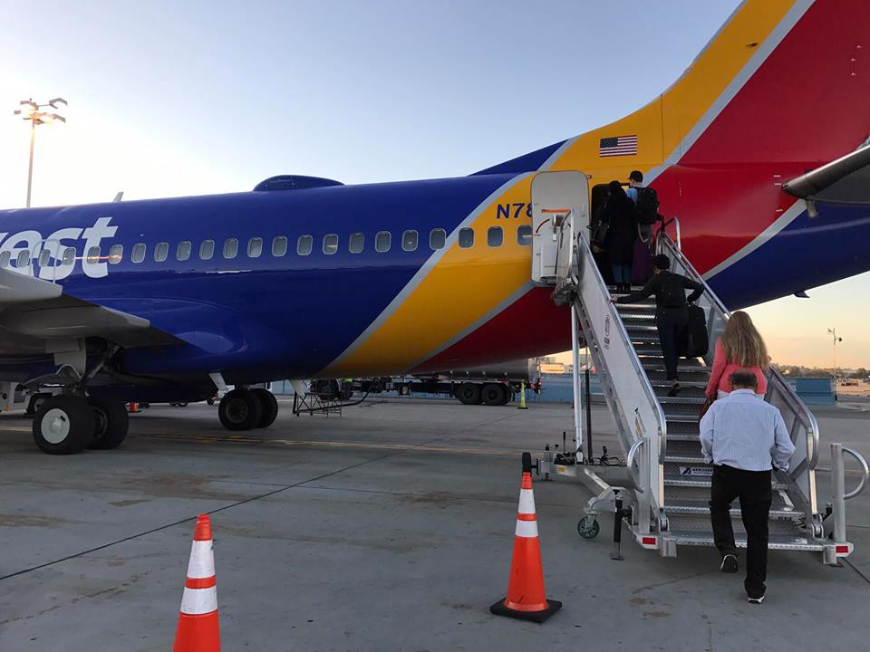

**Raised ceiling in waiting area Passengers boarding aircraft**

Conclusion

On the return journey, our team noticed that there were two separate flights from Long Beach Airport to Oakland International Airport departing at exactly the same time. The flights were essential identical, only different because of conflicting airlines, making us wonder if a more optimal flight could’ve been created if the two flights were combined to one, using forced market that we propose.

Our project focuses on redistributing flights from LAX to more optimal airports within its relative proximity. Even though Long Beach is small, it is not as congested when compared to LAX. Our team’s visits to these two airports confirmed the facts we read online gave us a better understanding on the situations within these airports.

